Rhodoshop
  - Rhodope Region – Bulgaria
OWNERSHIP | PUBLIC
Program authority | Association of Rhodope Municipalities (ARM)
Program Delivery unit | Rhodoshop
Implementation Model | Energy Performance Contracting (EPC)  Separate Based Contracting (SBC)
Operating Services | Marketer  Aggregator  Facilitator  Financial advisor  Assessor
Projects Financed | Energy Efficiency (building retrofits)  Renewable energy  Street Lighting
Ambition/targets | 50% energy savings
Beneficiaries | Public sector (municipalities)
Funding Vehicle | Financial institutions  Investment funds  ESCOs
Financial Instruments | Equity/Own funds  Loans  Grants

Summary

The Rhodoshop program aims at assisting Rhodope local authorities to build technical, economic, legal and administrative expertise for a wider implementation of energy efficiency in small sized rural municipalities.
It is based on 6 major objectives:
Objective 1): Increase the capacities, skills and knowledge of Rhodope local authorities by creating of Rhodoshop – a One-Stop-Shop for energy efficiency initiatives in the Region based on the successful experience of the GRE-Liege financial model RENOWATT. Rhodoshop will be a procurement agency, acting on behalf of public authorities that undertakes energy retrofitting works in their own existing buildings and in street lighting.
Objective 2): Develop a pipeline of sustainable energy investment projects allowing for project aggregation and financing solutions minimizing transaction costs;
Objective 3): Come up with suitable financing solutions for the realization of energy savings in the Rhodope Region (e.g. EPC, Energy efficiency funds, bank loans, national funding sources, etc.).
Objective 4): Launch concrete sustainable investment projects in Rhodope municipalities amounting to 13,2 M€ within its 36 month project duration.
Objective 5): Ensure long-term impacts of the Rhodoshop efforts after the life-time of the project by engaging in a dissemination program within Bulgaria and within EU for project results multiplication.
The main sectorial focus of Rhodoshop proposal is on existing public buildings and street lighting. At a later stage it will be considered also focusing on private buildings through supporting the implementation of a National Program for Energy Efficiency in Bulgarian Homes (Bulgarian governmental initiative providing funding for private households). The target of 8,8 GWh/year energy savings by the end of the project will be carefully monitored during its lifetime, together with the investment pipe-lines developed within the project.
The program initially involves 6 municipalities, all members of the Association of Rhodope Municipalities (ARM), which has 16 members in total. The 6 pioneering members are Banite, Chepelare, Devin, Nedelino, Smolyan and Zlatograd, of which 5 are engaged within the Covenant of Mayors. This joint undertaking is substantiated by the fact that these municipalities are neighboring each other and have had previous collaboration.
The program is co-managed by the Sofia Energy Centre (SEC).
The program is funded under the Horizon2020 PDA initiative. Training on the set-up and management of a One-stop-shop Program Delivery Unit (PDU) is provided by GRE Liège.
The proposed initiative builds upon the outputs of H2020 CITYnvest project (www.citynvest.eu) following the prepared Action Plan for the Rhodope Region which foresees the creation of the suitable infrastructure that will help Rhodope municipalities in securing funding, while taking into account organizational, administrative, legal and financial aspects. Rhodoshop proposal coordinating organization SEC is a partner in CITYnvest Project while ARM is a supporting organization in CITYnvest activities in Rhodope Region. GRE-Liege, the partner providing its innovative financial experience as part of CITYnvest, is collaborating with SEC and ARM for Rhodoshop establishment and making it operational, and will provide on-going consultations on practical issues during Rhodoshop implementation phase (via Skype and e-mail).

How does it work?
The Rhodoshop project aims at the implementation of an innovative financial model through the creation of a One-Stop-Shop to serve as central procurement agency thus enabling:
- to bundle projects from several small municipalities to gain critical mass;
- to focus on the public procurement of energy efficiency measures on the principles of Green Public Procurement in order to make the best choice of environmentally friendly, energy efficient and cost effective products and services. The idea of “Green Procurement” is to compare the qualities and performances of different solutions during their whole life-cycle, and to give preference to the solution that shows the best ratio cost/performance. Green procurement is also a tool for wider market penetration of innovative solutions for improvement of the energy characteristics of products and services, for the use of recycled materials and decrease of CO2 emissions.
The Rhodoshop project will ensure EU added value by replicating the innovative experiences of GRE-Liege for project aggregation and project bundling and financing solutions minimizing transaction costs on the Bulgarian market, and further disseminating this approach within Bulgarian local communities and at EU level.
In order to maximize the impact of the initiative on boosting sustainable energy investments in the region it is envisaged to involve the following main target groups:
- Municipalities from Rhodope Region. They will be involved through their membership to ARM which is a partner in Rhodoshop project that will accommodate the One-Stop-Shop structure and is therefore in a position to spread all available not confidential information to its remaining members;
- The rest of municipalities of Bulgaria – they will be targeted for project results multiplication efforts through the support of the National Association of Municipalities in the Republic of Bulgaria (NAMRB) which comprises of all 265 existing municipalities in the country and whose involvement is ensured by a Letter of Support;
- Europe-wide local authorities and other local actors – through the support of Climate Alliance, a European Network of 1713 municipalities from 26 European countries.
Other key project actors include:
- Association of Rhodope Municipalities (ARM) representing the 16 municipalities from Rhodope Region (including the six Rhodoshop pioneers) – project partner as Rhodoshop host organization;
- Sofia Energy Centre (SEC) – project partner providing management and coordination support to Rhodoshop structure through its vast experience in sustainable energy project execution at EU and national level, gained during its 22-year activity as a consultancy organisation;
- GRE-Liege – subcontractor with unique expertise in One-Stop-Shop creation providing training on the site through its involvement in the study tour of Rhodoshop staff to exchange practical experience on One-Stop-Shop function and on-going support during the Rhodoshop operational phase.
The overall approach is to set-up a dedicated Program Delivery Unit (PDU) that will undertake all functions of participating municipalities related to the whole development and implementation cycle of sustainable energy investments at the same time providing the opportunity to bundle and package smaller projects together in order to increase projects financial viability and get better terms from project financiers. The unit will be staffed with a dedicated team with respective competences and additional training will be provided on specific topics relevant to the program sectors and themes.

Fig 1. Operational and financial model

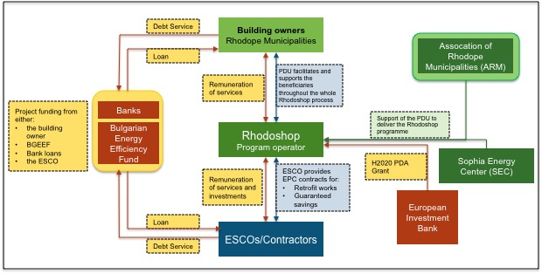

The program delivery unit

Rhodoshop will legally be part of ARM, with clearly defined objectives and principles of function stated in its Founding Act and with a dedicated team of five persons working full time on the Rhodoshop pilot program. The main provisions of the Rhodoshop Founding Act will cover neutrality of the structure which is important for local authorities and other stakeholders, its non-for-profit status being legally accommodated within ARM, its intermediary role as a facilitator and a procurement agency for subscribed municipalities. It sets the main rules of functioning and defines several aspects of the collaboration between the beneficiaries contracting authorities and the central procurement agency, as follows:
- The object and the role of the central procurement agency;
- The memberships conditions to the central procurement agency;
- The beneficiaries contracting authorities’ commitments towards the central procurement agency;
- The beneficiaries contracting authorities’ commitments in an EPC;
- Responsibilities of the central procurement agency;
- Distribution of roles regarding the contract notice;
- Distribution of roles regarding the execution of the contract;
The main roles and responsibilities of Rhodoshop as a procurement agency will be as follows:
Role | Facilitator role
Functioning/mechanism | It concludes public works, supplies or services contracts or framework agreements on behalf of the contracting authorities/entities or public institutions. Its role is in principle limited to launching the procedure and awarding the contract
Responsibilities | Once the contract is notified, each beneficiary is responsible for the completion of the procedure. There is a contractual relation between the tenderer and each beneficiary (each beneficiary who has acceded to the agreement).
Activities | - acts as an Assistant to the Contracting Authority for the client  - the contracts are concluded between the client and the ESCO’s  - acts as a facilitator: selection of the buildings, draft of the specifications, selection of the financiers (ESCO’s and others) and negotiations with them  - searches for financing for the cities and municipalities;  - may offer management of EPC’s services to the municipalities

The Rhodoshop PDU will have the following operating services:
- Marketing and communication: to inform the beneficiaries of the types of offerings available to them.
- Facilitation and client support:
  - Acts as a central procurement agency on behalf of the subscribed municipalities - the facilitator who concludes public works, supplies or services contracts or framework agreements on behalf of the contracting authorities/entities or public institutions;
  - Act as a knowledge center;
  - Gather competences and resources in one place (audits, works to be realized, financial viability calculations, define tendering specifications and assess received offers against pre-defined criteria).
  - Helps identify financing solutions applicable to different municipalities/clients – as Rhodope municipalities are of different size they are eligible for financing under different schemes. The PDU will investigate the opportunities and will identify suitable financing sources depending on client’s profile.
  - Assist in finding and negotiates the terms and conditions with ESCOs and other financiers;
  - Monitor project results
- Project Bundling
  - Bundle projects across different clients / municipalities which allows to diversify the risks, get better financing mechanisms, makes synergies across the retrofit projects and attract professional companies
  - Increase the size of the projects and the investment size
  - Create more attractive investment opportunities for building contractors, ESCOs, maintenance companies, financial Sector
The staff is composed of the following people:
- Rhodoshop Manager
- Rhodoshop technical expert
- Rhodoshop economic/financial expert

Legal structure | Integrated in ARM
Shareholder description | N/A
Equity | N/A
Shareholders | ARM
Program dedicated staff | Low – < 5 FTE
Program operational costs | Moderate

Organization and partnerships

The organizational scheme is as follows:

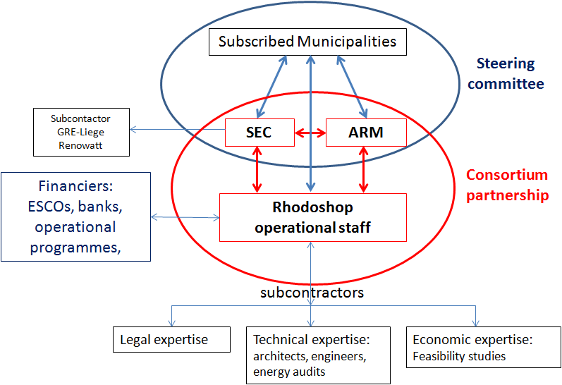

Partners include the National Association of Municipalities in Republic of Bulgaria (NAMRB) and Climate Alliance.

Beneficiaries
Beneficiaries | Municipalities in the Rhodope region
Type of projects | Energy Efficiency (building retrofits)  Street lighting projects
Operational support | Project facilitation through the Project Delivery Unit
Financial support | Project facilitation costs free of charge for 3 years

Funding mechanism

PDU Funding
The PDU and initial program coordination and communication is funded through a Horizon 2020 Project Development Assistance (PDA) grant for a total amount of 470 k€.
Project Funding:
One of the main responsibilities of Rhodoshop structure is to assemble an investment scheme for the developed project pipelines. It will play a facilitator role in securing funding by searching for suitable financiers matching the specific project requirements, contacts and negotiations with them on behalf of subscribed local authorities and securing the best possible terms for agreement with the funding body selected.
The following options have been considered for the elaboration of investment projects financial plan:
- Third party financing (TPFs) and ESCOs
  - For street lighting: Ullichno osvetlenie EAD (Street Lighting Ltd.) – private shareholder company performing an ESCO contract for street lighting refurbishment, maintenance and operation with Sapareva Banya Municipality since October 2015.
  - For public buildings: ENEMONA Ltd. (for measures to improve building shell), Erato Compnay (for biomass heated boilers in public buildings), Dalkia Veolia Energy Varna (only for building energy management contracts, not investing in retrofits),
- Bulgarian Energy Efficiency Fund (BGEEF)
Bulgarian Energy Efficiency Fund combines the functions of financing/guaranteeing institution and a consultancy center. The fund offers soft loans, partial credit guarantees (PCGs) and ESCO portfolio guarantees opportunities for municipalities and can be used in combination with ESCO funding and bank loans. Eligible for financing are (among others) public buildings and street lighting refurbishments.
  - Loans
BGEEF provides loans to municipalities with maximal tenor of 7 years, interest rates within the range of 4,5-8 % and minimal equity contribution of 10 to 25 % depending on co-financing source. The minimum equity contribution from the Project Developer for the proposed project shall be, as follows:
    - At least 10% for co-financing mode "BGEEF - commercial bank"
    - At least 25% for EERSF (BGEEF) stand-alone financing.
There are no additional credit conditions (taxes) and the repayment schedule is structured according to the need of the Project Developer. The conditions are the same for BEEF direct financing and for co-financing with a commercial bank.
  - Partial Credit Guarantees (PCGs)
PCGs against an annual fee of 0,5-2 %, while individual project guarantee commitments shall not exceed 400 000 Euro with a maturity of maximum 7 years.
  - ESCO portfolio guarantees.
The fund can be used in combination with ESCO involvement as it provides ESCO portfolio guarantees In this scheme ESCOs would bid for a project and then go to a bank to secure finance for it, or have a line of financing ready and fill it in with projects. The shortcoming of this approach is that typical ESCOs rely heavily on raising debt to fund their performance contracts. This requires that the cash flow of their business is very accurately timed and budgeted. Delayed payments from clients, or defaulting clients may severely disrupt the servicing of the debts of the ESCO itself. With its ESCO portfolio guarantee, BGEEF undertakes some of the risk of the ESCO and guarantees that it will cover such disruptions in the flow of receivables of the ESCO. BEEF has had several project cooperations under this scheme with the Bulgarian ESCO ENEMONA.
- Public subsidies and revolving funds
Energy retrofitting is currently financed mainly through national operational programs that comprise of EU Funds plus national co-funding. The general policy in the next program period 2014-2020, though, is to shift the balance towards more schemes of revolving funds (i.e. loans) and less direct subsidies (stated on page 12 of the new program Regions in Growth) which reflects the general EU policy is to redirect the efforts of local authorities towards securing commercial funding for their sustainable energy actions.

Program delivery unit funding | Rhodoshop got funding from H2020 PDA (470 k€)
Projects Funding | Projects are being funded through third party financing, loans and grants
Funding Vehicle | Financial Institutions  ESCOs  Energy Efficiency funds
Fund size | Not applicable
Fund type | Not applicable
Fund sources | Unknown
Financial Instruments | Own funds  Loans  Grants

Achievements (Targets)

The initial program targets 11,5 Million € of investment in 42 buildings, for a total surface of 85.429 m² and 1,7 MEuro in street lighting networks.It aims to achieve 8 800 MWh/year of energy savingsand 544 MWh/year of renewable energy production.
In addition, the program foresees 1,7 Million € of investment in street lighting systems, aiming at 1.356 MWh/year energy savings and 14,8 tons of CO₂ savings. Average payback is 14,8 years.

Contact details

Ivanka Pandelieva
Sophia Energy Center
GALITCHITSA 37 ENTR 2 2ND FLOOR
1164 SOFIA
Bulgaria

E-mail: ivankap@sec.bg
M +: 359 887317835
T + 359 2 9628447
F + 359 2 962 8447

Factsheet

General Info
Country | Bulgaria
Model Name | Rhodoshop
Date of creation | Ongoing

Model Description
Ownership | Public
Program authority | Association of Rhodope Municipalities (ARM)
Program delivery unit | Rhodoshop
Operating services | Marketer  Aggregator  Facilitator  Financial advisor  Assessor
Implementation model | Energy Performance Contracting (EPC)  Separate Based Contracting (SBC)
Types of projects financed | Energy Efficiency (Buildings retrofit)  Renewable Energy projects  Streetlighting projects
Beneficiaries | Municipalities in the Rhodope region
Geographical coverage | Regional

Financial Model Description
Project funding | Public/Private
Project funding vehicle | Property owners  Financial institutions  Energy Efficiency funds  ESCOs
Financial instruments | Loans  Grants  Own funds
Repayment model | Guaranteed savings agreement (for EPC)

Project risk Profile
Performance risk | ESCOs (for EPC)
Recourse | n/a
Financial risk | Building owners  Financial institutions

Model Requirements
Staff Requirements | Low  < 5 FTE
Equity Requirements | n/a
Funding Requirements | Low  Less than 1M €

Model Key indicators
Investment volume targeted | 13,2 M€
Size of project (or project portfolio) | 0,06 M€ to 6,6 M€
Level of average energy savings | 25% - 85%

Development maturity
Development/implementation stage | Start-up
Operational development maturity | Start-up
Financial development maturity | Start-up

Model Qualification
Level of establishment | Well established
Growth potential | Large
Scalability of the model | High
Replicability of the model | High
Impact on public balance sheet | High

